.



Astro

HoY

DHT

HoY

SLT

Main Office

SLT

CZ/RL3

CZ/RL1

CZ/RL2

IN3

CZ/RL4

PE1

PE2

AR3

AR4

Stage

DD1

SPORTS HALL

GYM

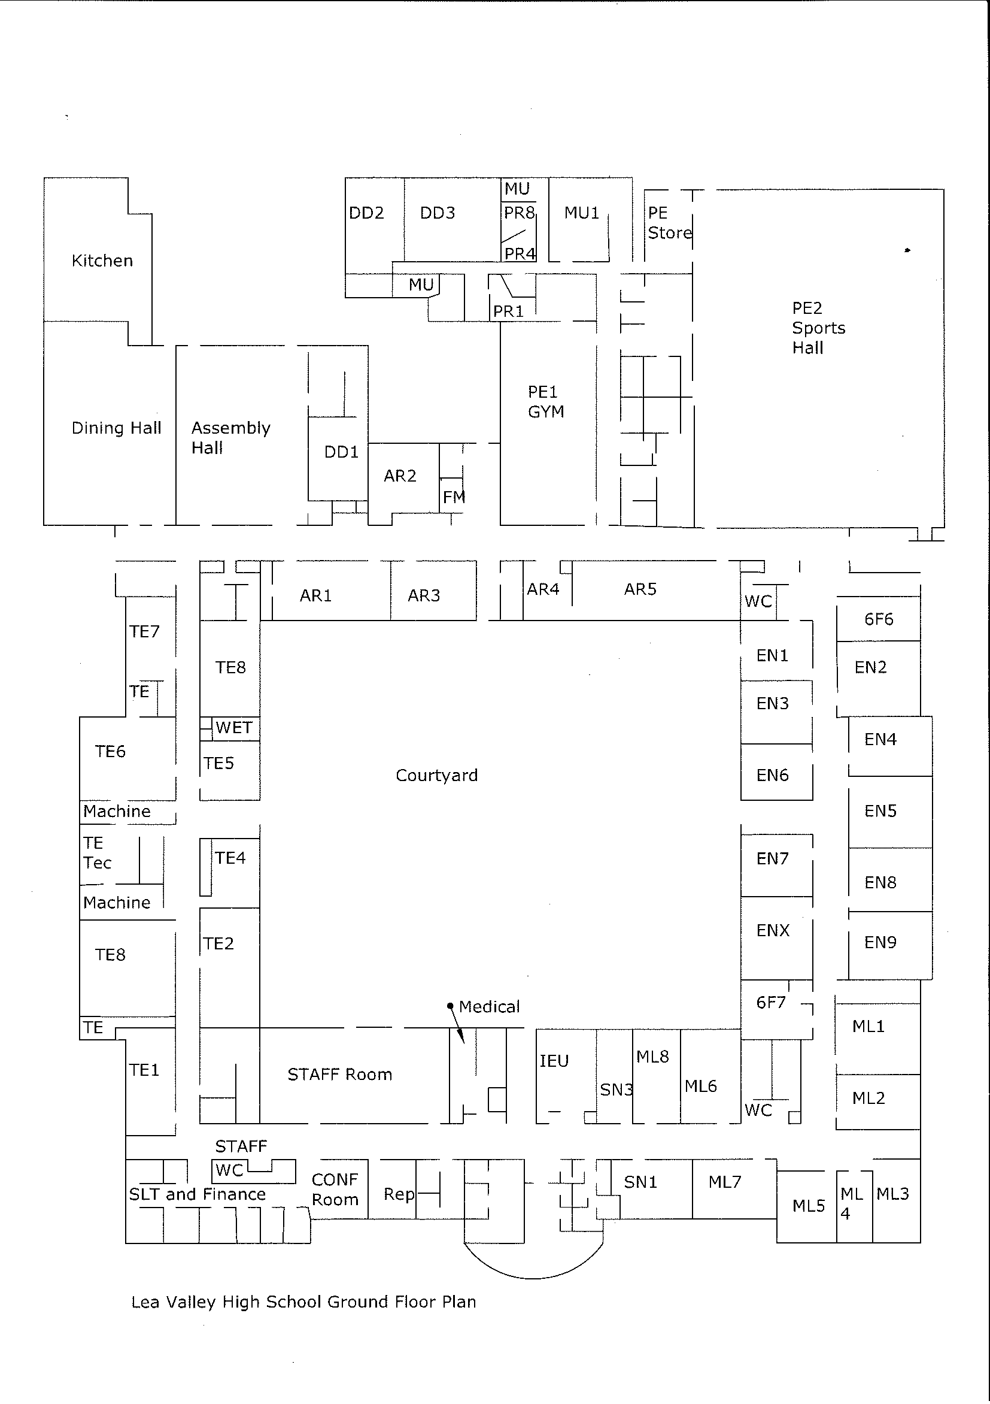

Lea Valley Academy – Ground Floor

SN2

TE3

We would require 3 Tables and 3 chairs and this will allow 3 people to sit down for the people that are selling the cakes at the bake sale and the 3 tables will allow us to layout the products that we are selling for people to see and having 3 tables will allocate enough space for us to layout the cakes and other products without it being too crammed